Inventory Survey:
Projects for Continuous Improvement in Beef Sustainability

The Canadian Roundtable for Sustainable Beef (CRSB) has a vision to be the go-to forum for sustainability conversations. Part of this work includes communicating the continuous improvement of the Canadian beef industry's sustainability. Recognizing that there are multiple players in this field, CRSB has a role in communication and coordination. To support improvements in future updates of the National Beef Sustainability Assessments (NBSA), CRSB is looking to profile projects that build on the following goals identified in the National Beef Sustainability Strategy.

What is a Project for Continuous Improvement? Any project that demonstrate, pilot, or promote practices that contribute to advancing one of the goals.
Applied research and technology transfer could be considered demonstration but they need to be at a commercial scale, target a specific audience and link to a specific practice that supports one of the goals. These projects are frequently local or regional in nature, as they address issues for specific ecosystems, habitats and production practices that are often influenced by weather and natural resources.
Primary research projects while contributing to the conversation and advancing knowledge in these areas are excluded from this survey.
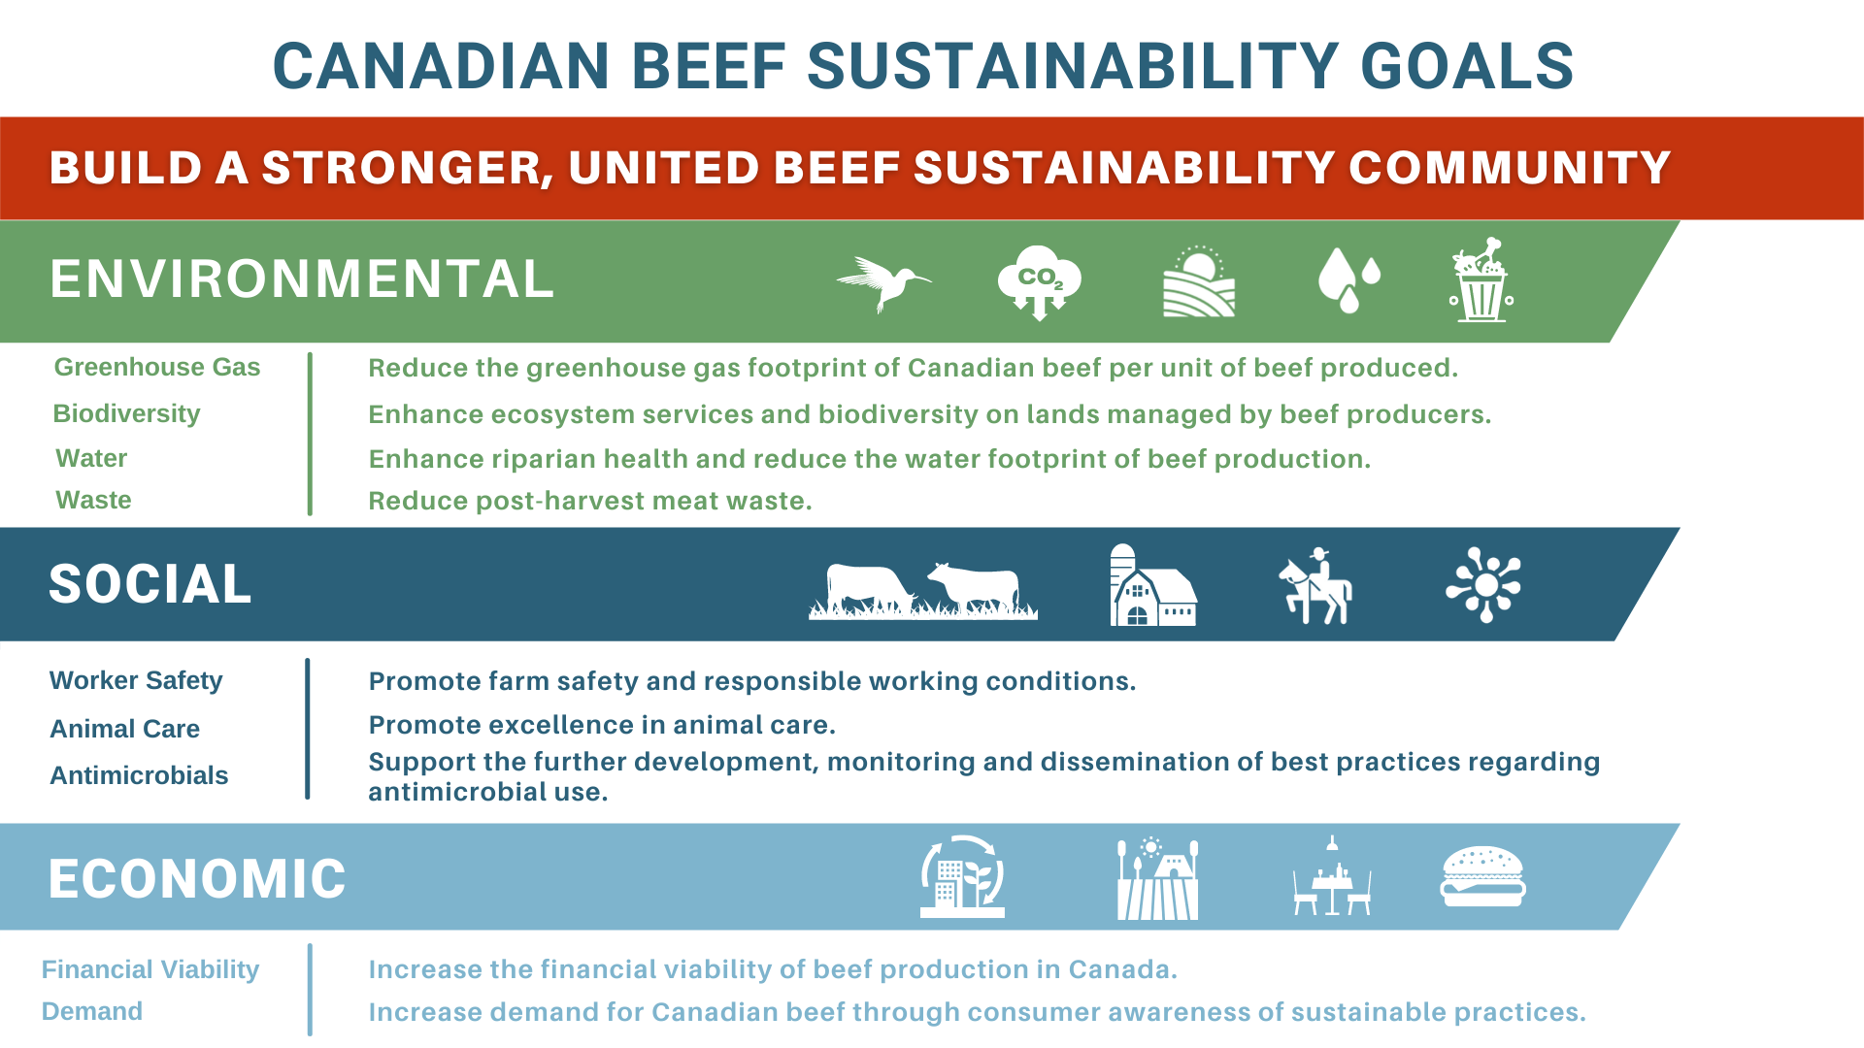

Participants: This survey is open to all CRSB members and non-members. We encourage you to forward the survey to your contacts and partners with whom you have projects that contribute.
Instructions for Completion: This document outlines the information that is needed to complete the online survey and is only intended to help you prepare your answers to the survey questions.
Please complete the survey online at https://www.surveymonkey.com/r/projectinventory2022
(copy & paste link if it doesn’t automatically connect).
Process for inclusion on website inventory map: Projects will be evaluated based on documentation submitted through the online survey, with priority given to projects that meet multiple goals and align with CRSB priorities. Projects that meet the necessary requirements will be reviewed by the Scientific Advisory Committee, where approval for inclusion on CRSB’s inventory map webpage will be given. CRSB reserves the right to exclude any project for any reason based upon the discretion of the Scientific Advisory Committee.
Website recognition: The participating organization acknowledges that inclusion of a project on the CRSB website is intended solely for the purpose of supporting communication and networking efforts within the Canadian beef sustainability community; such acknowledgement in no way whatsoever constitutes an agreement by the CRSB to fund the project set forth in the sustainability project inventory, and that any implication is unauthorized and invalid.
Thank you for your participation in the Projects for Continuous Improvement Inventory Survey with the Canadian Roundtable for Sustainable Beef (CRSB). For more information on the CRSB vision and mission please visit crsb.ca.
Projects for Continuous Improvement: Inventory Survey

Company/organization(s):
Contact name:
City: |  | Province:
Email:
Phone number:

CRSB Membership Status:
Member ⃝
Non-Member ⃝

Project name: _________________________________________________

Start Date: _____________________ End Date:______________________

Briefly describe the project objectives and activities (200 word max – to be posted on the CRSB website if approved):

List the principle investigators or key staff involved in the project, including their titles and organizations.

List any partners involved in the project (Include name, organization – allows us to identify duplicate entries):

Identify which CRSB goal the project is most closely associated with? Check only one.

- Reduce the greenhouse gas footprint of Canadian beef per unit of product produced
- Enhance ecosystem services and biodiversity on lands managed by beef producers
- Enhance riparian health and reduce the water footprint of beef production
- Reduce post-harvest meat waste
- Promote farm safety and responsible working conditions
- Promote excellence in animal care
- Support the further development, monitoring and dissemination of best practices regarding antimicrobial use
- Increase the financial viability of beef production in Canada
- Increase demand for Canadian beef through consumer awareness of sustainable beef production

If demonstrating, piloting or promoting the CRSB indicators (as outlined in the Sustainable Beef Production Standard or Sustainable Beef Processing Standard found at https://crsbcertifiedsustainablebeef.ca/); list the metrics/indicators you are measuring.
For example, demonstrating how different riparian management practices impact water quality or demonstrating how a grazing management plan can include soil health considerations or identifying food waste and loss and implementing practices to reduce landfill waste.

Briefly describe how you plan to share, scale up, or communicate the project results to advance sustainability practices in the beef sector. Provide an indication of where publications or communications materials are expected to be found. For completed projects, that have ongoing communications about adoption of practices that support continuous improvement, please provide links to any communication materials (200 word max.)

List all postal codes that the project is active in (This is needed to tag locations in the inventory)

Which sectors of the beef value chain are being targeted with communications to encourage sustainable practices? Check primary audience(s) only.
Cow-calf |  | Retail
Feeder |  | Foodservice
Packer |  | NGOs
Processor/Food Manufacturer (value added) |  | Institutions/Academics
Government |  | Consumers

Do you have another Project?
- If yes – online tool will repeat project questions.
- If no, survey will end.

